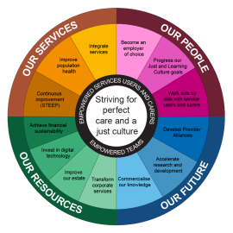
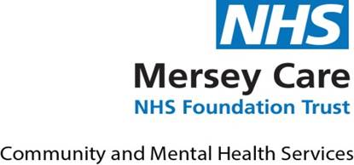

Nursing, Midwives and Allied Health Professionals
Research & Innovation Forum

Date: | 18th September 2026 | Time: | 9:00am-12:30pm
Venue: | Rooms 1&2 V7, King’s Business Park, Prescot

 | Item | Lead
9-9:15am | Arrive & Refreshments
9:15 – 9:30 | Research Culture: Idea Framework | Oladayo Bifarin
9:30-10:00 | Research Capacity and Capability - Development Programmes for Early Career Researchers (health and care) in the North West Region | Ms Jo Simpson, COO and programme lead and Amanda Craig, CEO NHS R&D North West
10:00-10:15 | Break
10:15-10:30 | Research Capacity: Suicidal Outcome in Mental Health Nurses: a systematic review of prevalence, risk factors and support mechanism | Lizzie Davies  PhD Researcher
10:30-10:45 | Research Culture: Obtaining Organisational Support | Kathryn Savage  Highly Specialist Speech & Language Therapist  South Sefton Adult Community SaLT Team
10:45-11:00 | Research Capacity and Capability: My Experience of the NIHR HCP Internship | Rachel Walsh  Lead Research and Clinical Trials Pharmacist
11:00 – 11:20 | Break
11:20 – 11:35 | Research Capacity: ALTO100-211 Clinical Trial for Bipolar Disorder with Depression | Gladys Madzamba  Senior Research Nurse  MCFT
11:35 – 11:50 | Research Capability: NIHR INSIGHT Programme: Inspiring People into Research – Research Master’s funding for early career health care, social work, and public health professionals | Colette Miller  Senior Research Fellow, NIHR INSIGHT Programme North West Programme Lead
11:50-12:10 | Research Capacity and Capability: Children and Young People's research | Jenny Gilchrist/Rachel Crick  Research Nurse – Children & Young People (CYP)  Mental Health Research for Innovation Centre
12:10-12:30 | Closing comments | Nicki Fearon  Assistant Director of Nursing  MCFT

